**Author:** Ankit Kumar Singh

**Student-ID:** x19205121

**Module:** Blockchain

**Professor:** Eoin Connolly

**GitHub:** https://github.com/ankitsingh2577/ankit_blockchain_project

**Address of Contract:** 0x450c1515BDa91a589f885F9A5eFcbbF3bc1bfA40

**ETH address of Token owner:** 0x051e0B533cD9B81d8fD60396ed06FBFC2d66b502

**Docker Hub url:** https://hub.docker.com/repository/docker/ankitsingh2577/ankit_blockchain_project

**Pull docker image:** docker pull ankitsingh2577/ankit_blockchain_project:2577

**why this assignment was chosen and its relationship to the ICO boom of 2017 / 2018**

An initial coin offering or initial currency offering is a kind of financing using cryptocurrencies. It is often a form of crowdfunding, however a private ICO which doesn't look for public speculation is additionally conceivable (no lawyers, bankers or regulatory approval required). In 2017 ICO Market Grew Nearly 100x From Q1 To Q4 ( [Crunchbase’s tracking of ICOs](https://www.crunchbase.com/search/funding_rounds/312e16ab357404ebdabfe83f7716b97f16d10ffb))an shown in figure 1, although from insights its evident that ICOs have been around since 2013. From 2012 to 2016, new companies that created or tackled blockchain innovation collected expanding amounts of cash from investors. The 2017 counting didn’t stop and goes on and raised more money in the first three months of 2018 than the whole of 2017. This revolution in cryptocurrencies has given the limelight to the startups using ICO’s (MobileGo and Polybius were eagerly oversubscribed when they launched and were among the top ICO offerings of 2017) and they mined the huge amount that was never expected to turnaround.

This assignment is chosen to understand the working of cryptocurrencies like Ethereum (decentralized applications). How contracts can be used to send token or ether from one account to another or many accounts using cod-based mechanism and also to have interactive learning experiences and experiment with Ethereum development. They are secured using cryptography, which makes it fault-tolerant against hacking attacks and false activities. As, from the 2017 boom in cryptocurrencies its a need for a developer to understand ICO. A high percentage of ICO’s is managed through smart contracts running on Ethereum blockchain, and in particular to ERC-20 Token standard contract. Form the coinmarketcap.com website, I found that the financial data of 450 ICO tokens available among which 355 Token are managed on Ethereum blockchain. This assignment also enables us to learn how to connect solidity contract with Node Js code using Web3 and host contract on Ropsten testnet to perform transaction from our local machines. To conclude Ethereum blockchain (ERC-20) has played the major role in 2017 and 2018 ICO boom in cryptocurrencies, which model the study of Ethereum blockchain an essential commodity for a blockchain developer.

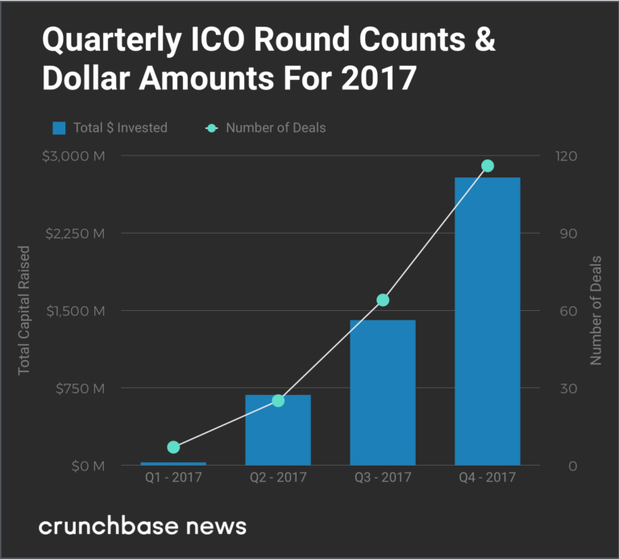

Figure 1